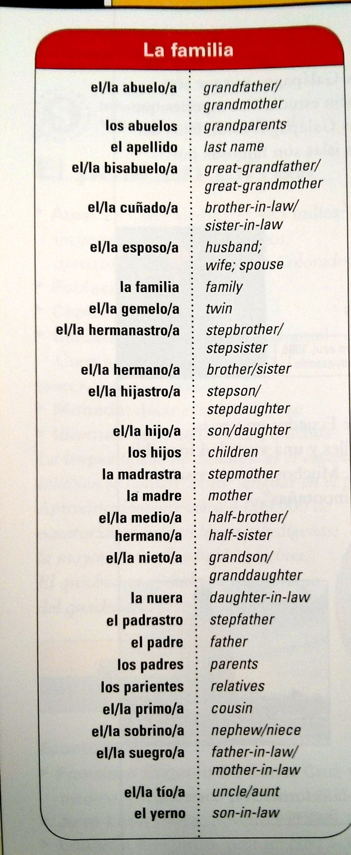
Una representación de tu familia
  - Un repaso del vocabulario familiar

Create a shape (tree or something else creative) that represents your family. In the tree you can include and label parents, grandparents, aunts and uncles, cousins, and especially focus on tíos-abuelos as they are part of the story. Some examples of shapes would be a box of crayons labeled with family members’ names and relationships, a flower with petals to represent family members, a cloud with raindrop family members.

Fecha de entrega: J-25/9/14 (día A) V-25/9/14 (día B)

Más palabras
- Tío/tía-abuelo
Great-uncle/aunt

