See pg. 241 of your Realidades 1 textbook for more information on the presentation assignment.

The following rubric will be used to grade your presentation.
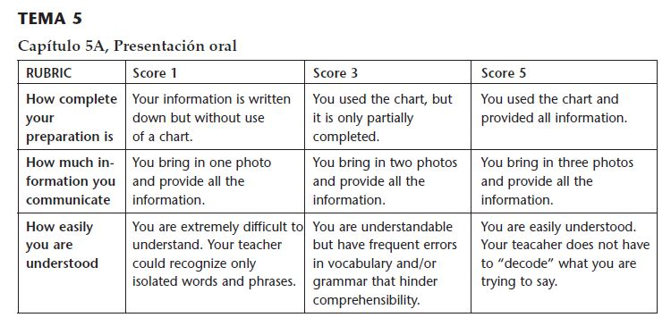
Before presenting, check:
- I completed a chart to plan what to say about all three people.
- I brought 3 physical photos or emailed 3 photo files to Srta. H before class.
- I practiced my presentation using complete sentences including vocab and phrases from the chapter.
- I will speak LOUDLY and clearly in Spanish so that my teacher can understand everything I say.

