Physical copy of Unit 4 Writing Proficiency Test Prep Draft
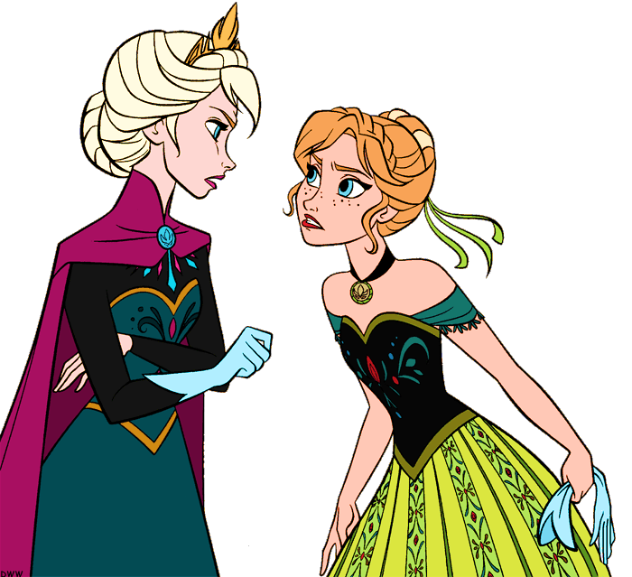
Escribe sobre un conflicto que ocurre entre dos amigos(as) en una película que viste o entre amigos(as) de la vida real. Explica por qué se rompe la armonía y cómo se reconcilian esas personas. ____________________________________________________________________________________________________________________________________________________________________________________________________________________________________________________________________________________________________________________________________________________________________________________________________________________________________________________________________________________________________________________________________________________________________________________________________________________________________________________________________________________________________________________________________________________________________________________________________________________________________________________________________________________________________________________________________________________________________________________________________________________________________________________________________________________________________________________________________________________________________________________________________________________________________________________________________________________________________________________________________________________________________________________________________________________________________________________________________________________________________________________________________________________________________________________________________________________________________________________________________________________________________________________________________________________________________________________________________________________________________________________________________________________________________________________________________________________________________________________________________________________________________________________________________________________________________________________________________________________________________________________________________________________________________________________________________________________________________________________________________________________________________________________________________________________________________________________________________________________________________________________________________________________________________________________________________________________________________________________________________________________________________________________________________________________________________________________________________________________________________________________________________________________________________________________________________________________________________________________________________________________________________________________________________________________________________________________________________________________________________________________
Comentarios:

