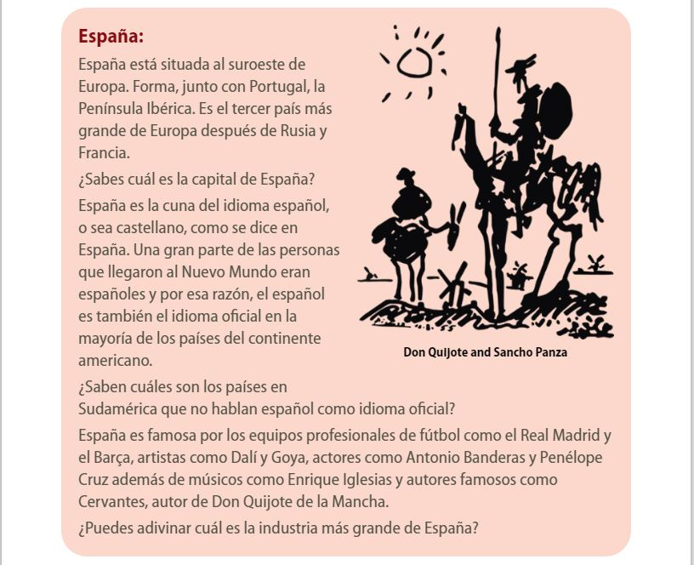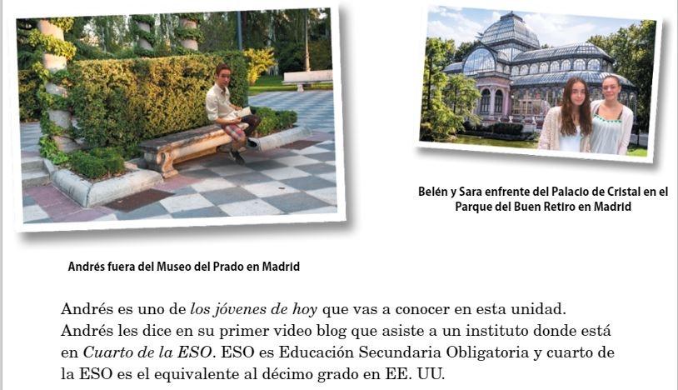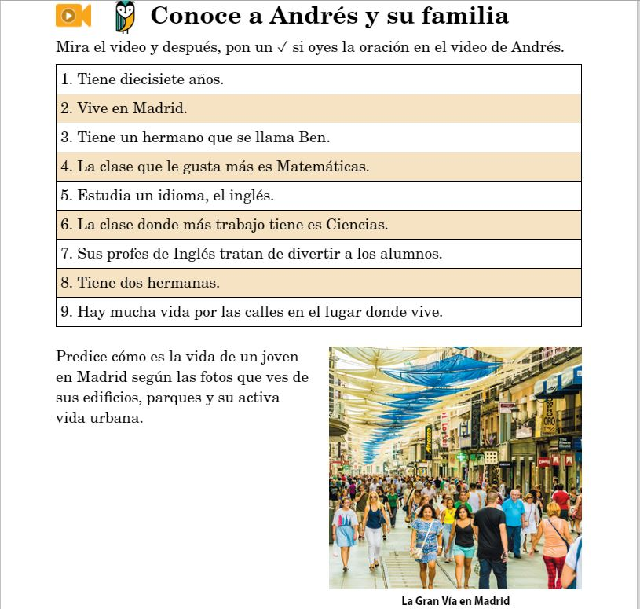

**1**

**2**

**3**

________________________________________________________________________________________________________________________________________________

________________________________________________________________________

________________________________________________________________________

________________________________________________________________________